Payroll Management System for Information Technology Company

Use-Case Specification: Add report

Version 1.0

Revision History

|  |  |  |  |
| --- | --- | --- | --- |
| **Date** | **Version** | **Description** | **Author** |
| 28/12/2019 | 1.0 | Final | Nguyen Khac Phuc |
|  |  |  |  |
|  |  |  |  |
|  |  |  |  |

Table of Contents

1. Add report 4

1.1 Brief Description 4

2. Flow of Events 4

2.1 Basic Flow 4

2.2 Actor 4

3. Special Requirements 4

3.1 Requirement Fields. 4

4. Preconditions 5

5. Postconditions 5

6. Extension Points 5

6.1 <Name of Extension Point> 5

# Add report

## Brief Description

This use-case defines the step of add a report. Admin can easily create a report by fills in all the require fields such as title, content, description.

# Flow of Events

## Basic Flow

* Users log in with the admin account. Admin clicks manage salary button, then clicks add report button. After that, the add report frame appears, admin fills in all the fields and click submit button then the system will show the success message or show the failed message.

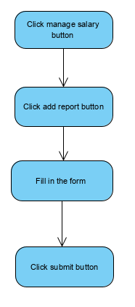

## Actor

-Administrator

# Special Requirements

## Requirement Fields.

* All the fields must be filled before submit.

# Preconditions

* User must log in into the system with the admin account

# Postconditions

* Show message if create report success, the system will show message create successfully or else the system will show message failed

# Extension Points